

Brent Clinical Commissioning Group
Harrow Clinical Commissioning Group

H

HEALTH AND SOCIAL CARE FUNDING TOOL FOR ASSESSING JOINT PACKAGE DECISIONS FOR AGREEMENT AT S117 PANEL- OLDER PEOPLE

Patient Name:

DOB:

NHS number:

Date of assessment:

Names of assessors:

- If funding percentage split is not agreed by the continuing care panel, (and there are health needs that cannot be met by existing services), then the Health and Social Care S117 Funding Tool should be used.

- A health professional and a Social Worker will use the information contained in their health and social care assessment (including other assessments if appropriate e.g., GP, District Nurse, consultant etc.) to complete each domain in the Funding tool.

- This information is then given a score (A-E), which is agreed by those completing the form and is determined by using the descriptors for each domain also contained within this document.

Instructions for completion

- Individually the Nurse and Social Worker should review the 16 domains on the following pages and make a decision as to which score most closely matched the patient’s needs; - A, B, C or D

- These scores are then transferred onto the scoring form and a numerical score calculated for the total score as per guidance below: Please note the different numerical values which apply depending on whether it is the Social Worker or Nurses assessment. Following the simple calculation, a percentage contribution from both Health and Social Services is arrived at on the scoring form.

- Where disagreement persists, it may be useful to request that a third assessment is completed by either a Doctor, or another health or Social care Professional.

- For use with older people with mental health difficulties.

 | A – No support required | B – Requires support from carers | C – Requires assistance from carers with qualified health staff available for advice | D – Requires skilled care from carers under close supervision from qualified health staff and/or qualified health staff input required x1/week | E – Qualified health staff required to deliver care on a daily basis +/- assistance from carers
1. Behaviour | Behaviour appropriate to context. No Support required. | Some mildly abnormal behaviour or troublesome to others eg persistent swearing, poor personal hygiene and alcohol or substance misuse, which requires monitoring and/or support from carers. | Abnormal, inappropriate and maladaptive behaviour including moderate alcohol or substance abuse resulting in reduced ability to cope with own affairs; and requires assistance from carers with daily living activities; and needs occasional support from qualified health staff. | Behaviour markedly abnormal; and requires skilled management from carers under close supervision; or needs at least a weekly review or interventions from qualified health staff. | Serious behaviour problems (eg self neglect, deliberate self harm or high risk of suicide or risk/to from others); or constant physical outbursts and aggression; and unable to cope with own affairs; and requires 24 hour management from qualified health staff.
2. Cognitive Functioning | No support required. | Usually able to reason and think adequately but may have occasional difficulties and require support or assistance from carers. | Cognitively impaired but usually able to make decisions if offered limited options and guidance; and requires assistance from carers with daily living activities; and needs occasional support from qualified health staff. | Marked cognitive impairment but able to contribute to decision making if offered limited options, guidance and reassurance through continuous skilled support from carers under close supervision; or needs at least a weekly review from qualified health staff. | Severe cognitive impairment and requires 24 hour management from qualified health staff.
3. Psychological well-being | Mood within normal boundaries. No Support required. | Low mood or mild anxiety; or loss / adjustment / bereavement issues that require monitoring and support from carers. | Psychological difficulties affect daily functioning and assistance is required from carers with daily living activities; and needs occasional support from qualified health staff. | Moderate to severe anxiety or depression or other mental health problem requiring at least a weekly qualified health staff review or intervention eg counselling / psychotherapy. | Severe mental health problems causing severe incapacity, risk of self-harm, suicide or harm to others, which requires 24-hour management from qualified health staff.
4. Communication and understanding | No monitoring or support required. | Minimal communication difficulties but needs supervision or monitoring from carers to ensure that necessary equipment is used correctly; or occasional assistance with daily living activities. | Communication difficulties that require close attention by carers and/or confirmation to clarify needs, views or understanding; or requires regular assistance from carers with daily living activities; and needs occasional advice from qualified health staff. | Limited communication and understanding using a range of verbal and non-verbal abilities and/or electronic aids; and requires skilled input from carers to interpret needs and views; and needs at least a weekly review from qualified health staff. | Very limited communication and understanding eg low awareness states; and interpretation requires qualified health staff over a 24-hour period.
5. Mobility and transfers | Independent. No assistance required. | Needs prompting only; or requires supervision / assistance from carers. | Requires assistance of carers; and needs occasional advice from qualified health staff. | Requires skilled input from carers under close supervision; or at least a weekly review by qualified health staff. | Qualified health staff needed to safely meet mobility and transfer needs +/- assistance from carers.
6. Eating and drinking | Can eat and drink independently. No assistance required. | Needs prompting to take food and drink; or requires supervision / assistance from carers. | Swallowing difficulties mean that feeding takes >1hr with assistance from a carer; or uncomplicated PEG management; or requires qualified health staff for crisis management | Severe swallowing difficulties with skilled feeding orally by carer under close supervision; or complicated PEG management requiring at least weekly input from qualified health staff. | Oral feeding can only be undertaken by qualified health staff with regular daily need for suction; or qualified nurse required for TPN (Total Parental Nutrition).
7. Bladder Management | Independent. No assistance required. | Continence well managed =/- aids (eg catheters/stoma/pads) but needs prompting; or requires supervision / assistance from carers to use toileting facilities. | Continence usually managed with aids or strict toileting regime (eg 2 hourly) but may have occasional episodes of urinary incontinence; and requires assistance from carers; and needs occasional advice from qualified health staff. | Bladder management requires skilled input from carers under close supervision; or clean intermittent catheterisations required; or catheter problems require qualified health staff interventions at least weekly. | Intractable urinary incontinence not effectively controlled using aids or a toileting regime; and qualified health staff needed to manage continence +/- assistance from carers.
8. Bowel Management | Independent. No assistance required | Continence well managed with oral medication and/or aids (eg pads/stoma) but needs prompting; or requires supervision / assistance from carers to use toileting facilities. | Continence usually managed with medication or aids or strict toileting regime (eg 2 hourly) but may have occasional episodes of faecal incontinence; and requires assistance from carers; and needs occasional advice from qualified health staff. | Bowel management requires skilled input from carers under close supervision; and requires suppositories, enemas or other skilled interventions eg manual evacuations; or needs at least a weekly review by qualified health staff. | Intractable faecal incontinence not effectively controlled using medication, aids or toileting regime; and qualified health staff needed to manage continence +/- assistance from carers.
9. Skin and wound care | Skin intact, no monitoring required. | Observation and monitoring of pressure areas required by carer; May require pressure-relieving equipment. | Minimal pressure problems or minor broken skin; and pressure relieving equipment required; and needs occasional input from qualified health staff. Likely to have a Waterlow score between 10-15. | Moderate pressure sores requiring at least a weekly review / input from qualified health staff; and pressure relieving equipment required. Likely to have a Waterlow score between 15-20. | Severe pressure sores with daily input required from qualified health staff in order to manage skin breakdown. Likely to have a Waterlow score higher than 20.
10. Breathing | Able to breathe independently. No monitoring required. | Needs infrequent monitoring, supervision or assistance from carer to ensure that equipment or position to aid breathing is used correctly. | Requires frequent assistance from carers to use equipment or to position correctly; and qualified health staff needed for occasional advice or for crisis management. | Breathing difficulties require skilled input from carers to achieve correct positioning under close supervision; or intermittent oxygen therapy; or night time ventilation required. | Unable to breathe independently and permanent mechanical ventilation required; or continuous oxygen therapy; or daily tracheotomy care required.
11. Symptom Control | No monitoring of symptoms required. | Infrequent or frequent, but predictable symptoms well managed, which require monitoring on intermittent basis by carers. | Infrequent or frequent, predictable or unpredictable, but not serious or life threatening symptoms which require regular monitoring from carers to maintain stability; and needs occasional advice from qualified health staff. | Predictable or unpredictable, potentially serious symptoms, which require regular skilled monitoring and/or interventions from carers under close supervision; or needs at least a weekly review from qualified health staff. | Frequent and unpredictable, life threatening symptoms requiring monitoring, review and/or interventions throughout a 24-hour period from qualified health staff.
12. Medication | Able to self medicate. No assistance required. | Needs prompting; or requires supervision from a carer or assistance to access medication. | Requires supervision or assistance with medication; and needs occasional advice on medication from qualified health staff. | Requires supervision or assistance with medication; and medication requires monitoring at least weekly by qualified health staff. | Medication needs to be administered by qualified health staff eg injections.
13. Personal Care | Independent. No assistance required. | Needs prompting only; or requires supervision / assistance from carers. | Requires assistance of carers; and needs occasional advice from qualified health staff. | Requires skilled input from carers under close supervision; or at least a weekly review by qualified health staff. | Qualified health staff needed to safely provide care +/- assistance from carers.

HEALTH AND SOCIAL SHARED CARE S117 FUNDING TOOL – INFORMATION FORM

NAME: D.O.B___________

 | DOMAIN | BAND | RATIONALE
1 | BEHAVIOUR
2 | COGNITIVE FUNCTIONING
3 | PSYCHOLOGICAL WELL-BEING
4 | COMMUNICATION AND UNDERSTANDING
5 | MOBILITY AND TRANSFERS
6 | EATING AND DRINKING
7 | BLADDER MANAGEMENT
8 | BOWEL MANAGEMENT
9 | SKIN AND WOUND CARE
10 | BREATHING
11 | SYMPTOM CONTROL
12 | MEDICATION
13 | PERSONAL CARE

CARE MANAGER HEALTH PRACTITIONER

Signature: Signature:
Position: Position:
Date: Date:

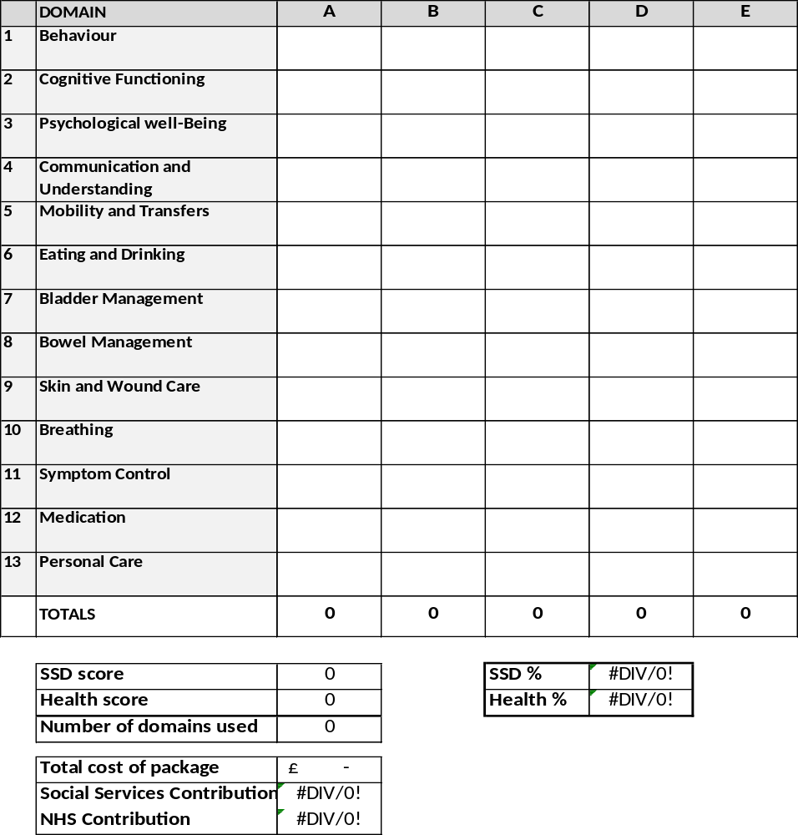

SCORING SYSTEM FOR HEALTH AND SOCIAL SHARED CARE NEEDS TOOL

1, Firstly calculate the final number (F) of scoring items as follows:-

F = 13 – (the total score in column A)

(Scores in column A are assigned a value of 0 for both social services and health as this column identifies areas of independence where social or health care support is not required).

2. Numerical points are then assigned to each score in the columns B, C, D, E as follows:-
Social Services Health
B 1 0
C 0.75 0.25
D 0.25 0.75
E 0 1

3. Use the following formula to establish the total scores:-

SSD Score = B + (C total x 0.75) + (D total x 0.25)

Health Score = (C total x 0.25) + (D total x 0.75) + E total

4. Percentage of social needs and health needs are worked out using the following formula:-

% Social needs = SSD score x 100%
F

% Health needs = Health score x 100%
F



